

EvoScan Gauge Layouts Tutorial

Contents

EvoScan Gauge Layouts Tutorial 1
1 What are Gauges and Layouts? 2
2 Creating Gauge Widgets 3
3 Parts of Add New Gauge Widget Screen 4
3.1 Template Selection 4
3.2 Gauge Refresh Rate 5
3.3 Open Folder 5
3.4 Edit Template 5
3.5 Create New Template 6
3.6 Gauge Area 9
3.7 Context Menu 10
3.8 Create New Widget 11
3.9 Close Button 11
4 Gauge Widgets 12
5 Gauge Layouts 13

1 What are Gauges and Layouts?

Gauge Layout is a collection of one or more gauges. You can create your own gauge layouts using the Gauge Layout features described in this document.
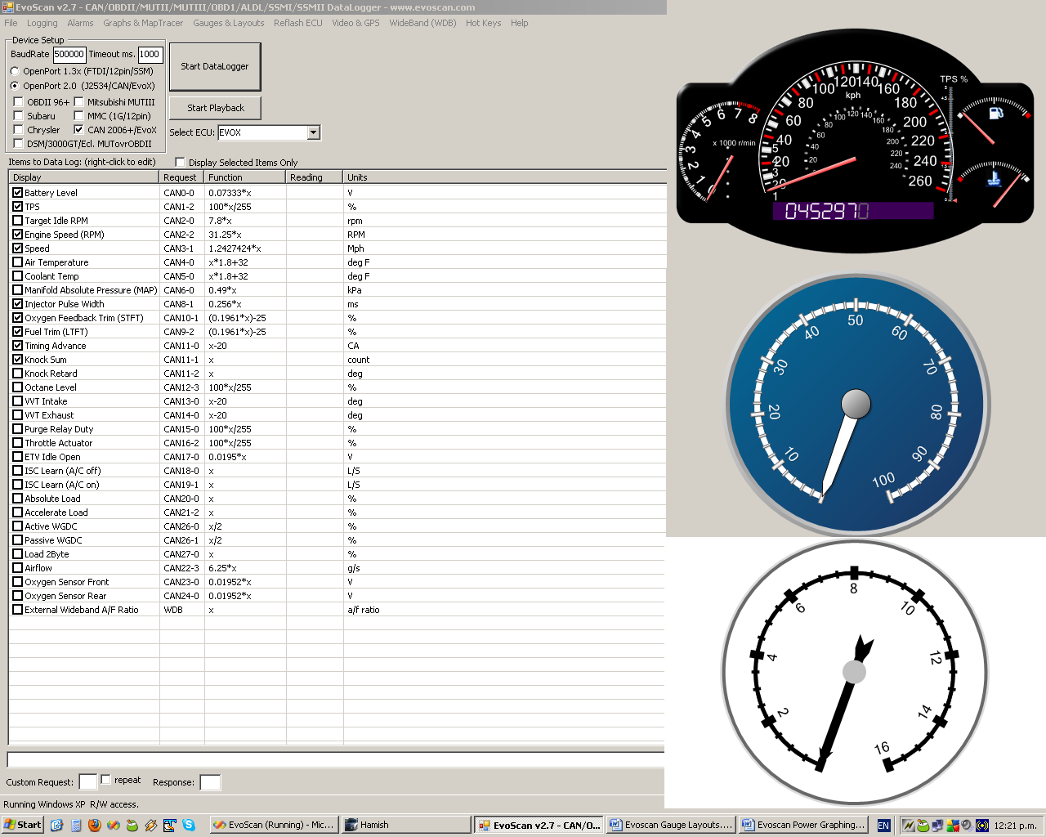
Img1: Gauge layouts

2 Creating Gauge Widgets
You can create new Gauge Widgets and edit existing Gauge Widgets by opening Gauges & Layouts –menu on the Evoscan main screen and selecting Add/Edit Gauge Widgets. Gauge Layouts are formed of one or more gauge widgets.
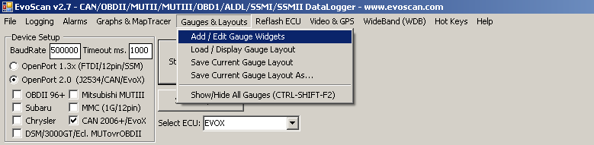
Img2: Opening Add/Edit Gauge Widgets screen on the EvoScan main screen.

3 Parts of Add New Gauge Widget Screen

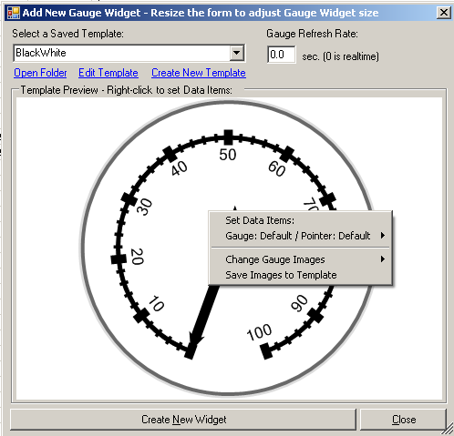
1 Template Selection
2 Gauge Refresh Rate
3 Open Folder
4 Edit Template
5 Create New Template
6 Gauge Area
7 Context Menu
8 Create New Widget
9 Close Button

Img3: Different parts of Add New Gauge Widget screen.

3.1 Template Selection
To start building a new Gauge Widget you need a template. You can create templates for circular gauges, linear gauges, numeric indicators, state indicators and full dashboards that can consist of several gauges and indicators. Typical uses for Circular Gauges are speedometers, compasses and clocks where as thermometers and progress tracking devices would more commonly be monitored by Linear Gauges. Numeric Indicators offer a numeric representation of the values and are mainly used in conjunction with a linear or circular gauge. Common uses for State Indicators are warning lights and weather condition markers. EvoScan comes with several ready made templates of each type. Available templates are as follows:
- Circular Gauge Templates
  - Black & White
  - Blue
  - Graphite
  - Grey
  - LCD
  - NiceRed
- Numeric indicator templates
  - Digital
  - Digital_BlackGold
- State indicator templates
  - KnockIndicator
  - KnockIndicator2
- Dashboard templates
  - Dash2
  - DashBoard
You can also create your own templates and when saved in the templates folder they will appear in templates selection list. When you select a template it will be shown in Gauge Area. To adjust the size of the gauge you can resize the window.

3.2 Gauge Refresh Rate
Next step after selecting your template is to set refresh rate for the widget. Enter the desired refresh rate in redraws per second, zero meaning real-time. The lower the refresh rate, the greater the accuracy of the gauge but also, keep in mind that high refresh rate is directly proportional to high memory and processor consumption and anything over 5 updates per second will not be visible.

3.3 Open Folder
Open Folder link opens the template folder in an explorer window for you to view and edit template xml files manually.

3.4 Edit Template
Edit Template link opens Gauge Wizard window where you can edit selected template.
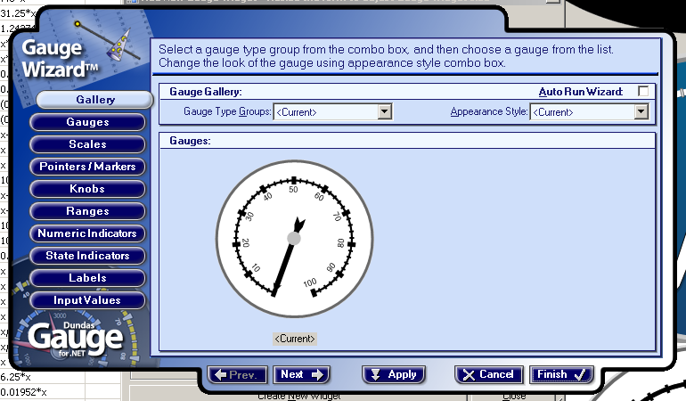
Img3.4:Gauge Wizard screen.

3.5 Create New Template
Create New Template link opens Gauge Wizard where you can create new templates. Below is the step-by-step guide of creating gauge templates. To move onto a next page on the wizard click Next button on the bottom of the screen or the name of the page on the left hand side of the screen. You can go back to a page by pressing Prev. on the bottom of the screen or the name of the page on the left hand side of the screen.
- Gallery - Gauge Type: Select gauge type. There are three different types of gauges, circular gauges, linear gauges and numeric indicators.
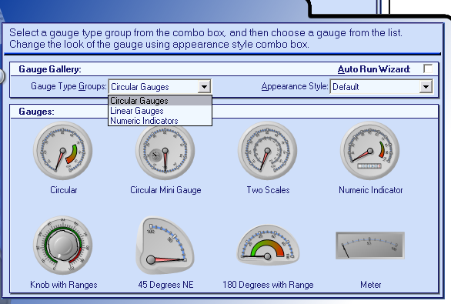
- Gallery - Appearance Style: Select a template for your gauge. If an element which is a pre-defined type (e.g., meter) is selected, then all the elements of the GaugeContainer will be sized in proportion to that control. This means that if after selecting a style from the wizard, you cannot view all of the Gauge elements, just resize the control to resize all Gauge elements within it.
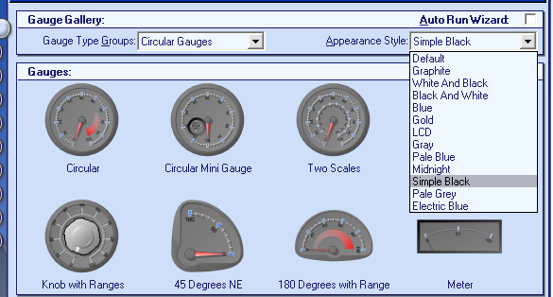
- Gallery - Gauge Base: After you’ve selected your gauge type, you can select one of the predefined gauges as a base to your gauge.
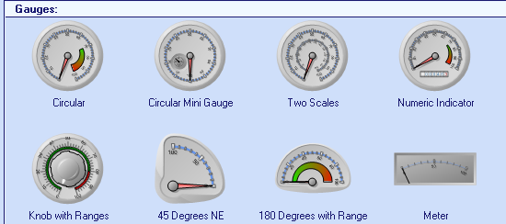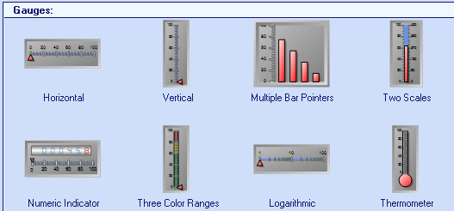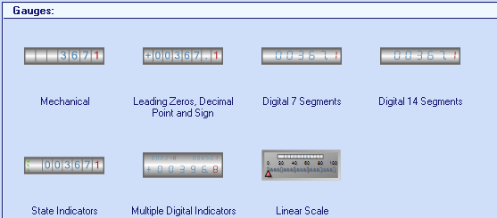
- Gauges - Position: First tab on the Gauges page is position. Here you can set the position and the size of the gauge and also select a parent element for the gauge. Press Selected Gauge and a list of gauges opens up where you can add new gauges, delete gauges and rename them. You can add several gauges into your gauge container but note that having more than three gauges in a container may decrease the performance if using a high refresh rate.
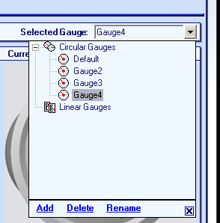
- Gauges - Gauge Frame: On Gauge Frame tab you can select the colours and border for the gauge frame.
- Gauges - Container Frame: Container Frame tab lets you set the container frame appearance, colour and border.
- Scales - Scale: You can create new scales onto your circular or linear gauges by clicking Selected Scale and pressing Add. First tab on the Scales page is Scale. Here you can set the appearance of the scale, colours, radius, sweep angle etc. Sweep Angle property only available for circular gauges, is number of degrees the scale will sweep in a circle i.e. 360 would be a perfect circle. Start Angle property, also only available for circular gauges, is the angle of rotation where the scale will begin, i.e. start angle of 90 would start the scale 90 degrees clockwise from the bottom of the scale. Logarithmic selection means that base 10 is used for the logarithmic scale. Scales - Labels: On the Labels tab you can select the position, colour, font etc. for the gauge labels.
- Scales - Major Ticks: Here you can select whether you want major ticks to be visible and their appearance. Major Ticks are the primary value markers of the gauge and usually the ticks with value labels.
- Scales - Minor Ticks: Here you can select whether you want minor ticks to be visible and their appearance. Minor ticks are the secondary value markers between the major ticks and don’t usually have labels to represent their values.
- Pointers/Markers – Type/Scale: On this tab you can create pointers and set the appearance of your pointer/marker by selecting the type (needle/marker/bar), style, size, placement etc. To create a new pointer/marker click Selected Pointer and then press Add. Each pointer is associated with a scale that can be selected in pointer scale dropdown box.
- Pointers/Markers – Input/Behaviour: Input/Behaviour tab lets you set input values to a pointer so that you can display calculated values. You can also set your pointer behaviour such as dampening or snapping. Dampening smoothes value and Snapping rounds the values to the interval determined.
- Pointers/Markers – Appearance: The last tab lets you set colour and border for your pointers/markers.
- Knobs – Type/Scale: You can add a knob onto your gauge by clicking Selected Knob and clicking Add. Knob will be added to the selected gauge. You can add several knobs onto a gauge. After creating a knob you can set the style and size for the knob and also for the knob marker.
- Knobs –Input/Behaviour: Input/Behaviour tab lets you set input values to a knob so that you can display calculated values. You can also set behaviour onto your knob such as snapping and dampening. Dampening smoothes value changes when displayed on the knob. Snapping rounds the values of the knob to an interval determined.
- Knobs – Appearance: On the last tab of the Knobs page you can set the colour and borders for your knob.
- Ranges – Scale/Position: Ranges are used to visually represent a set of values on a scale. You can add a new range onto your gauge by clicking Selected Range and clicking Add. Range will be added to the selected scale. You can add several ranges onto a gauge. After creating a range you can set the position and placement of the ranges.
- Ranges – Appearance: Appearance tab lets you select the colours and border of your ranges. To colour a range of tick marks on a scale you can set the scale tick marks colour.
- Numeric Indicators – Style/Position: You can create new numeric indicators here by clicking Selected Indicator and selecting Add. Numeric Indicators can be added, either as child objects of a circular or linear gauge, or as separate elements in the GaugeContainer. When adding a numeric indicator to a gauge container where a circular or linear gauge already exists, the Parent Element for the numeric indicator is set to the first gauge that was added to the container. Use this tab also to set the style and position of numeric indicators. There are three available types for numeric indictors; Digital7Segment, Digital14Segment and Mechanical. If you select Mechanical you can set any font where as fonts cannot be set for digital display indicators. If a character cannot be shown on the 7-segment indicator, it will be sown as “E”.
- Numeric Indicators – Input/behaviour: Input/behaviour tab lets you set input values to a numeric indicator to display calculated values. You can also set the behaviour for the numeric indicators. Numeric indicators provide a numeric representation of data, and a range may be set for each numeric indicator used. Dampening smoothes value and Snapping rounds the values to the interval determined.
- Numeric Indicators – Appearance: Here you can set the colour and border for the numeric indicators.
- State Indicators – Style/Position: You can create state indicators as a visual cue as to the different states of the data presented in a gauge. Use this tab to set the style and position of state indicators. If you don’t have any state indicators, skip this step. To create new state indicators click Selected Indicator and select Add. When adding a state indicator to a gauge container that already has gauges, the parent element of the state indicator is set to the first gauge added to the container. The three available styles for state indicators are RectangularLed, CircularLed, RoundedRectangularLed and Text.
- State Indicators – States: States tab lets you add new states for the state indicator and set the ranges and appearance for the states.
- Labels – Text/Position: Text/Position tab lets you set the labels for your gauges. To add a new label click Selected Label and then click Add.
- Labels – Appearance: Here you can set the font, colour and background appearance for your labels.
- Input Values – Input Values: Input values tab you can set the input value attributes for your gauges.
- Input Values – Formulas: On formulas tab you can add formulas for calculated values.

3.6 Gauge Area
Gauge Area shows the gauge based on the selected template. Some gauge templates have tooltip texts showing up when hovering over the gauge. You can resize the gauge by resizing the screen.
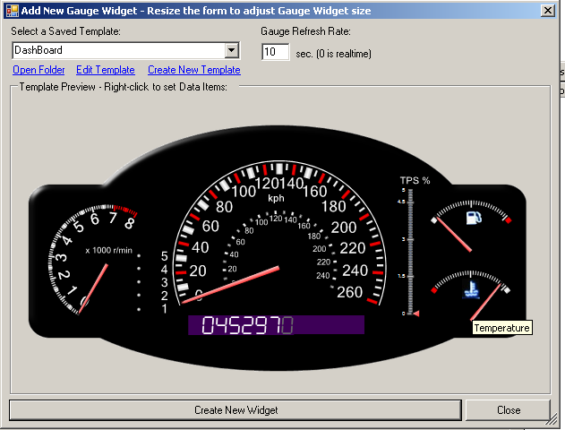
Img3.6: Some gauges have tooltips showing up.

3.7 Context Menu
Right mouse click on the gauge area opens up a context menu. The items in the menu are dependent on the type of gauge.
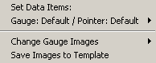
Img3.7.1: Gauge Context Menu

3.7.1 Set Data Items
The first item in the circular gauge context menu is “Set Data Items:”. This item is just informative and doesn’t have any functionality.

3.7.2 Gauge: Default / Pointer: Default
Gauge: Default / Pointer: Default selection opens up a list of available data items. This selection defines which item the gauge is going to monitor. If there is more than just one gauge on the template, you will see a menu item for each gauge.

3.7.3 Change Gauge Images
In Change Gauge Images menu you can change the image for Top Image, Container Image, Back Frame, Pointer and pointer cap for circular gauges and back frame and pointer for linear gauges. Top Images are images placed on top of a gauge container. Top Images can be used to create an effect of external casing which is placed over a gauge. For your gauge to be visible, top image must have a transparent area. Container Images (such as company logo etc.) are images placed at any location on the gauge. Image files must be in one of the following formats: BMP, EMF, EXIF, GIF, GUID, JPG, PNG, TIFF or WMF.

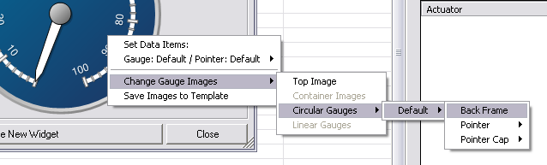
Img 3.7. Change Gauge Images context menu.

3.7.4 Save Images to Template
Use Save Images to Template to save the template.

3.8 Create New Widget
Create New Widget button creates a new widget on the screen based on the selected template. You have to choose a data item for you gauge before creating a widget.

3.9 Close Button
Close button closes the Add New Gauge Widget screen but not the widgets that are open.

4 Gauge Widgets

After you have created a gauge widget and it’s visible on your screen you can edit it by opening the context menu. You can change the data item, edit template, load a gauge layout, resize the gauge etc. Most of these options are the same as the ones in Add New Gauge Widget screen. Make Double Clickable is one of the exceptions. You can make your gauge to be double clickable and set it to run a command line execute, log data to file or log data to screen. With one of these options selected you can simply double click the gauge to perform the desired action. To disable double clicking, click on the selected option. Selection will be saved in the gauge layout but each selection is per gauge not per gauge layout i.e. you can have several gauges in your gauge layout with each of them having their own double clicking setting.

You can also move the gauge around by holding the mouse button down and dragging the gauge. Remember to save your layout after the changes.
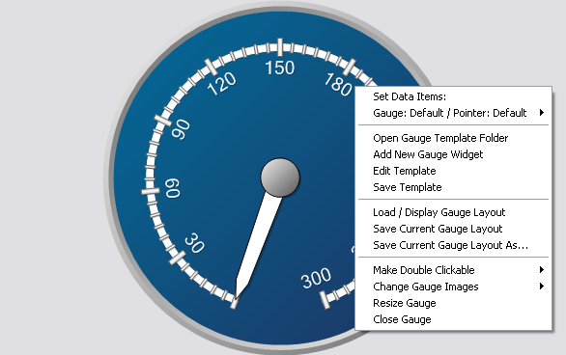
Img 4. Gauge widget context menu.

5 Gauge Layouts

Gauge Layout is a collection of one or more Gauge Widgets. You can load/display saved gauge layouts by selecting Load/Display Gauge Layouts in Gauges & Layouts menu. To create a new gauge layout, go to the Add New Gauge Widget screen and create as many gauge widgets as you wish to have on your layout, place them where you want them to be placed on the screen and save the created layout by clicking Save Current Gauge Layout on Gauges & Layouts menu. To show or hide gauges you can select Show/Hide all gauges in Gauges & Layouts menu or just by pressing CTRL+SHIFT+F2.

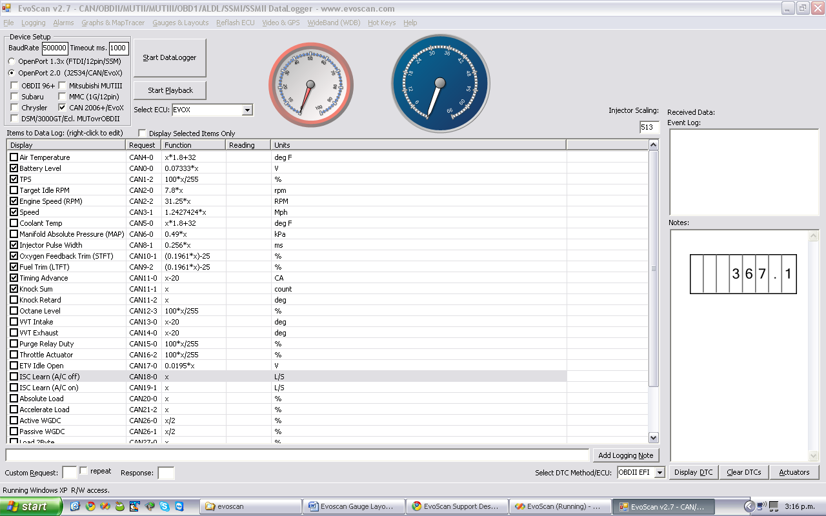
Img5. Gauge Layout consisting of two circular gauges and one numeric indicator resized and placed on different parts of the screen.

